December 27, 2022
«AddressBlock»

RE: Rezoning Petition 2023-002-LC
LCTM-Parcel 030-040
1.6 acres of land, more or less, Highway 196, Hinesville

«GreetingLine»
A rezoning petition has been submitted by Charlie Frasier, owner, to rezone 6.22 acres from AR-1 (Agricultural Residential District) to R-3 (Multi-Family Residential District) for apartments.
You received this notification as your property is located within 200 ft. of said property above.
The Liberty Consolidated Planning Commission will hold a public hearing on this rezoning petition January 17, 2023, at the Liberty County Annex, 2nd floor, 112 N. Main Street, Hinesville.
Subsequently, Liberty County Board of Commissioners will hear this item February 7, 2023, at the Liberty County Annex, 2nd floor, 112 N. Main Street, Hinesville.
You are invited to attend these meetings if you wish.
If you are in opposition to this rezoning petition and have made contributions aggregating $250.00 or more to any local government official considering this application in the two (2) years preceding the filing of this rezoning petition, by law you must disclose this fact five (5) days prior to the first hearing of this action if it is your intent to speak at this meeting.
Additional information in reference to this rezoning petition may be obtained by contacting the undersigned at the Liberty Consolidated Planning Commission at (912) 408-2034.
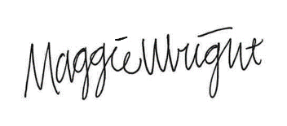
Maggie Wright, Planner
Liberty Consolidated Planning Commission
(912) 408-2034 Office
mwright@thelcpc.org

