June 23, 2026

RE: Rezoning Petition and Annexation 2026-27-R

Dear property owner,
You are receiving this letter because you own property that is within 200 feet of the property of June B. Salter, et al, at E. B. Cooper Highway (parcel # 166A001 - see reverse side of this letter). Liberty Properties and Holding Co., LLC, on behalf of owner June B. Salter, et al, has petitioned to rezone ±75.26 from AR-1 (Agriculture Residential) to PUD (Planned Unit Development) for residential development of single-family dwellings and townhomes. Annexation of a ±54-ac. portion of the property into the City of Riceboro has also been petitioned for. You are invited to attend and speak at the following public hearings regarding this request, if you wish:
- The Liberty Consolidated Planning Commission – July 21, 2026, at 4:30 pm, at the Liberty County Annex, 2nd floor, 112 N. Main St in Hinesville.

- The Riceboro City Council – August 4, 2026, at 6:00 pm at the Riceboro City Hall, 4614 S. Coastal Hwy in Riceboro.
If you are in opposition to this rezoning petition and annexation and have made contributions aggregating $250.00 or more to any local government official considering this application in the two (2) years preceding the filing of this rezoning petition and annexation, by law you must disclose this fact five (5) days prior to the first hearing of this action if it is your intent to speak at this meeting.
If you have any questions or would like additional information about this rezoning petition and annexation, please email me at lparks@thelcpc.org or call (912) 408-2041.

Sincerely,
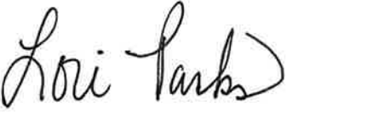
Lori Parks
Zoning Administrator

