December 27, 2022

«AddressBlock»

RE: Variance Request 2023-005-H
LCTM-Parcel 068C-007
916 Kings Road, Hinesville

«GreetingLine»
A Variance Request was submitted by Kevin and Arianna Goodrow for placement of a carport to be located on the side of the home as opposed to the back of the home as required by the R-1 (Single-Family Dwelling District) zoning regulations.
You received this notification as your property is located within 200 ft. of said property above.
The Liberty Consolidated Planning Commission will hold a public hearing on this rezoning petition January 17, 2023, at the Liberty County Annex, 2nd floor, 112 N. Main Street, Hinesville.
Subsequently, Hinesville Mayor and Council will hear this item February 2, 2023, at Hinesville City Hall, 115 E ML King Jr. Drive, Hinesville.
You are invited to attend these meetings if you wish.
If you are in opposition to this petition and have made contributions aggregating $250.00 or more to any local government official considering this application in the two (2) years preceding the filing of this rezoning petition, by law you must disclose this fact five (5) days prior to the first hearing of this action if it is your intent to speak at this meeting.
Additional information in reference to this petition may be obtained by contacting the undersigned at the Liberty Consolidated Planning Commission at (912) 408-2034.
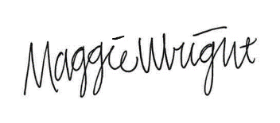
Maggie Wright, Planner
Liberty Consolidated Planning Commission
(912) 408-2034 Office
mwright@thelcpc.org

