April 28, 2026

Re: Conditional Use 2026-21-LC
Dear property owner,

You are receiving this letter because you own property that is within 200 feet of the property of Stephanie and Jacob Jones owners of Jones Creek Farms on Old Gress Island Road (parcel # 241D053 - see reverse side of this letter). Stephanie and Jacob Jones have submitted a conditional use for a retail space. You are invited to attend and speak at the following public hearings for this request, if you wish:
- The Liberty Consolidated Planning Commission – May 19, 2026, at 4:30 pm, at the Liberty County Annex, 2nd floor, 112 N. Main St in Hinesville.

- The Liberty County Board of Commissioners – June 2, 2026, at 6:00 pm, at the Liberty County Annex, 2nd floor, 112 N. Main St in Hinesville.

If you are in opposition to this rezoning petition and have made contributions aggregating $250.00 or more to any local government official considering this application in the two (2) years preceding the filing of this rezoning petition you must disclose this fact five (5) days prior to the first hearing of this action if it is your intent to speak at this meeting.
If you have any questions or would like additional information about this rezoning petition, please email me at lparks@thelcpc.org or call (912) 408-2041.

Sincerely,
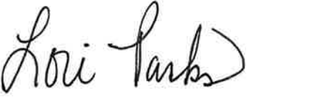
Lori Parks
Zoning Administrator

