April 28, 2026

RE: Variance Request 2026-22-R

Dear property owner,
You are receiving this letter because you own property that is within 200 feet of the property of Lillie and Angela Roberts at 58 Estella Lane (parcel # 166B002 - see reverse side of this letter). Derrick Spencer, on behalf of Lillie Roberts, has requested a variance for a side setback from 25 feet to 11 feet to replace a mobile home that was damaged in a fire. You are invited to attend and speak at the following public hearings regarding this request, if you wish:

- The Liberty Consolidated Planning Commission – May 19, 2026, at 4:30 pm, at the Liberty County Annex, 2nd floor, 112 N. Main St in Hinesville.

- The Riceboro City Council – June 2, 2026, at 6:00 pm, at the Riceboro City Hall, 4614 S. Coastal Hwy in Riceboro.

If you are in opposition to this variance request and have made contributions aggregating $250.00 or more to any local government official considering this application in the two (2) years preceding the filing of this variance request, by law you must disclose this fact five (5) days prior to the first hearing of this action if it is your intent to speak at this meeting.
If you have any questions or would like additional information about this variance request, please email me at lparks@thelcpc.org or call (912) 408-2041.

Sincerely,
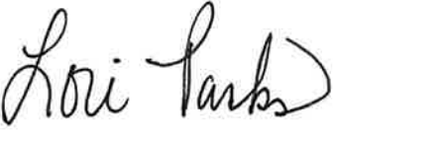
Lori Parks
Zoning Administrator

