March 19, 2026

Re: 2026-11-W
Dear property owner,

You are receiving this letter because you own property that is within 200 feet of the property of the Walthourville Meat Market at 5715 W. Oglethorpe Hwy. (parcel # 050C006 – (see reverse side of this letter). Javier Martinez has submitted a conditional use for a contractor’s yard. You are invited to attend and speak at the following public hearings regarding this request, if you wish:
- The Liberty Consolidated Planning Commission – April 21, 2026, at 4:30 pm, at the Liberty County Annex, 2nd floor, 112 N. Main St in Hinesville.

- The City of Walthourville – May 12, 2026, at 6:00 pm, at the Walthourville Police Department, 192B Talmadge Road in Walthourville.

If you are in opposition to this rezoning petition and have made contributions aggregating $250.00 or more to any local government official considering this application in the two (2) years preceding the filing of this rezoning petition you must disclose this fact five (5) days prior to the first hearing of this action if it is your intent to speak at this meeting.
If you have any questions or would like additional information about this rezoning petition, please email me at lparks@thelcpc.org or call (912) 408-2041.

Sincerely,
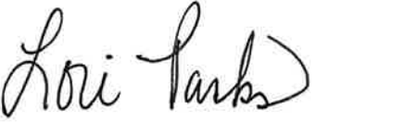
Lori Parks
Zoning Administrator

