December 5, 2022

«AddressBlock»

RE: Variance 2022-078-LC
Setback Variance for 390 Main Street
LCTM-Parcel 281D-045 (Lots 95 & 96)

«GreetingLine»
A variance request regarding a side yard building setback was filed by J. Wheeler Properties (Josh Wheeler), owner, to reduce the 15 feet required side yard building setback to 10 feet.
You received this notification as your property is located within 200 ft. of said property above.
The Liberty Consolidated Planning Commission will hold a public hearing on these variance requests December 20, 2022, at 4:30 pm, in the Liberty County Historic Courthouse, 2nd floor, 100 Main Street, Hinesville.
Liberty County Board of Commissioners will have a public hearing on this this item, January 3, 2023, at 6:00 pm, at the Liberty County Courthouse Annex, on the second floor, 112 N. Main St, Hinesville.
You are invited to attend both meetings if you wish.
Additional information in reference to this variance request may be obtained by contacting the undersigned at the Liberty Consolidated Planning Commission at (912) 408-2034.
Sincerely,
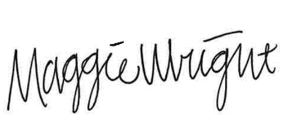
Maggie Wright, Planner
Liberty Consolidated Planning Commission
(912) 408-2034 Office
(888) 320-8007 Fax

mwright@thelcpc.org

