February 23, 2026

RE: Conditional Use 2026-06-LC

Dear property owner,
You are receiving this letter because you own property that is within 200 feet of the property of Zachary Zito at 2384 Mt. Olivet Church Road in Fleming (parcel # 203003) - see reverse side of this letter). Zachary Zito has submitted a conditional use request for a type B home occupation for a gunsmith business. You are invited to attend and speak at the following public hearings regarding this request, if you wish:

The Liberty Consolidated Planning Commission – March 17, 2026, at 4:30 pm, at the Liberty County Annex, 2nd floor, 112 N. Main St in Hinesville.

- The Liberty County Board of Commissioners – April 7, 2026, at 6:00 pm, at the Liberty County Annex, 2nd floor, 112 N. Main St in Hinesville.

If you are in opposition to this conditional use and have made contributions aggregating $250.00 or more to any local government official considering this application in the two (2) years preceding the filing of this conditional use, by law you must disclose this fact five (5) days prior to the first hearing of this action if it is your intent to speak at this meeting.
If you have any questions or would like additional information about this conditional use type B home occupation , please email me at lparks@thelcpc.org or call (912) 408-2041.

Sincerely,
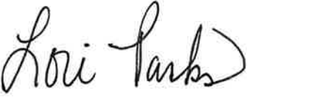
Lori Parks
Zoning Administrator

