Liberty Consolidated Planning Commission
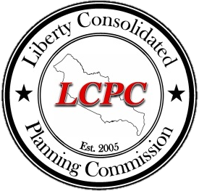
Governing Board
Agenda
October 5, 2015
1:00 PM
Hinesville City Hall
Administration Conference Room, third floor

- Call to Order Chairperson
- Certification of Compliance with Georgia Open Meetings Act
- Executive Session (Personnel Matters per O.C.G.A. 50-14-3(b)(2))
- Reconvene Public Meeting Chairperson
- Adjourn Public Meeting Chairperson

