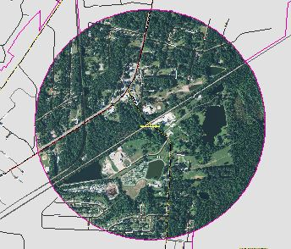
COMMUNITY PLANNING MEETING
FOR ALLENHURST SUBAREA –
JUNE 23, 2015

Meeting: June 23, 2015
Time: 6:00 PM to 7:00 PM
Location: Allenhurst Town Hall
4063 West Oglethorpe Hwy.
Hinesville, GA 31313

On Tuesday, June 23, 2015 the Allenhurst Town Hall will be the site of the eighth of 12 community planning meetings, hosted by the Liberty Consolidated Planning Commission, where residents can offer their input for the next Comprehensive Plan. The meetings will be conducted every month in locations that span from sand hills to salt marshes in Liberty County, Georgia.

The purpose of the community planning meetings is to review recent development trends in the area and receive public input regarding future decision making about land use, zoning and transportation. The information received from these meetings will be used to formulate the 2040 Liberty County Comprehensive Plan – A guide for the development of Liberty County and its communities during the next 25 years. The Comprehensive Plan will be used by city and county elected officials to make decisions on proposed land use developments, as well as transportation and infrastructure investments.

Community Planning Meetings

Allenhurst May-June 2015
Gum Branch/Rye Patch July-August 2015
Hinesville (West) Sept.-Oct. 2015
Hinesville (Mid) Nov.-Dec. 2015
Hinesville (East) Jan.-Feb. 2016

*This schedule is tentative and is subject to change.

The staff of the Liberty Consolidated Planning Commission met with citizens and elected official of Allenhurst on May 26th to present the current land use map and environmental constraints to aid in the development of a future land use map. Six changes were identified at the meeting and a future land use map has been developed. The proposed future land use map will be presented to the Allenhurst citizens for final review on Tuesday, June 23rd at 6PM at the Allenhurst Town Hall. The map will be presented to the Liberty Consolidated Planning Commission on Tuesday, July 19th and forwarded to the appropriate governing authority. This meeting is open to the public and public participation is desired.

For more information about the Allenhurst community planning meeting, maps or a schedule of future community planning meetings, please contact Melissa A. Jones at (912) 408-2038, mjones@thelcpc.org,

