COMMUNITY PLANNING MEETING
FOR MIDWAY AREA –
JANUARY 22, 2015

Meeting: January 22, 2015
Time: 6:00 p.m. to 7:30 p.m.
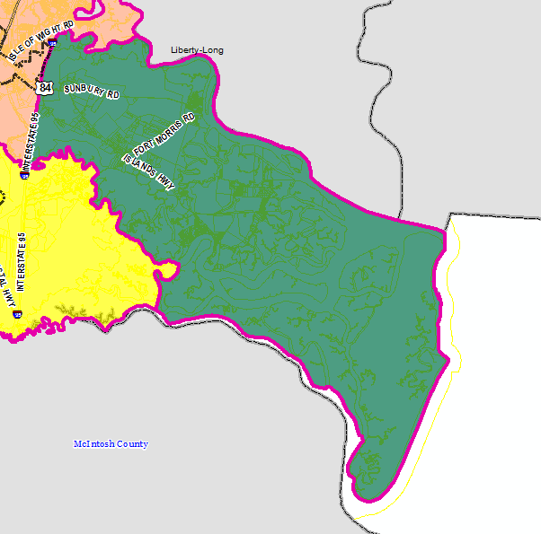
Location: Dorchester Village Civic Center
1804 Islands Highway
Midway, GA 31320

On Thursday, January 22, 2015, Dorchester Village Civic Center will be the site of the sixth of 12 community planning meetings, hosted by the Liberty Consolidated Planning Commission, where residents can offer their input for the next Comprehensive Plan. The meetings will be conducted every month in locations that span from sand hills to salt marshes in Liberty County, Georgia.

The purpose of the community planning meetings is to review recent development trends in the area and receive public input regarding future decision making about land use, zoning and transportation. The information received from these meetings will be used to formulate the 2040 Liberty County Comprehensive Plan – A guide for the development of Liberty County and its communities during the next 25 years. The Comprehensive Plan will be used by city and county elected officials to make decisions on proposed land use developments, as well as transportation and infrastructure investments.

The staff of the Liberty Consolidated Planning Commission will present current land use maps and environmental constraints to aid in the development of the future land use maps. The Sunbury/Islands subarea includes unincorporated areas of Liberty County and the coastal community. The subarea encompasses approximately 69,884 acres of land, with various land use classificaitons, including, but not limited to, residential, industrial, and dunes and marshland. The information gathered at the meeting will be used to update the future land use map and transportation plans for the Sunbury/Islands subarea and unincorporated areas of Liberty County. The meeting is open to the public and public participation is desired.
Community Planning Meetings

Sunbury/Islands Jan.-Feb. 2015
Walthourville March-April 2015
Allenhurst May-June 2015
Gum Branch/Rye Patch July-August 2015
Hinesville (West) Sept.-Oct. 2015
Hinesville (Mid) Nov.-Dec. 2015
Hinesville (East) Jan.-Feb. 2016

*This schedule is tentative and is subject to change.

For more information about the Sunbury/Islands community planning meeting, maps or a schedule of future community planning meetings, please contact Melissa A. Jones at (912) 408-2038 or via email at mjones@thelcpc.org,

